Travel Planner App

1. Description
Travel Planner App is an app that allows users to plan their trips more efficiently. It provides a platform for users to create, store, and manage all their trips in one place. It contains all the necessary information in order to plan trips, such as destination, start date, end date, budget, accommodation, activities, and transportation. Users can also add additional notes or comments to each trip.

2. Why is useful?
Travel Planner App is an incredibly useful tool for travelers. It enables users to easily manage their trips, from creating new destinations and adding transportations, accommodations and activities, to budgeting and tracking their progress. Additionally, the app provides users with the ability to save their plans for future trips, as well as the ability to store notes for each trip. Finally, Travel Planner App allows users to compare and contrast different trips in order to find the best options for their needs.

3. Basic functionalities

1. Create a Trip
Users can create a new trip by navigating to the 'Create a Trip' page and filling out the necessary information such as destination, start and end dates, budget, and notes. Once all the information has been filled out, users can click on the 'Create Trip' button to save their trip.

2. Add Destinations, Transportation, Accommodation and Activities
Once users have created a trip, they can add destinations, transportation, accommodation and activities to their itinerary. To add a destination, users can select the 'Add Destination' button and enter the desired location in the search bar. The app will then display a list of suggested destinations based on the user's search query. To add transportation, users can select the 'Add Transportation' button and choose from a list of transportation options such as bus, train, or car. The app will also recommend the best transportation and accommodation options based on the user's budget. To add activities, users can select the 'Add Activity' button and choose from a list of suggested activities such as hiking, sightseeing, or shopping.

3. View Statistics
Users can view statistics about their trips, such as total cost, number of days, and total distance traveled. This will help users easily track their progress and compare trips.

4. Save and Share
Once users have created their trip, they can save it for future use or share it with friends and family. To save a trip, users can select the 'Save' button and the trip will be stored in the app. To share a trip, users can select the 'Share' button and enter the desired email address. The shared trip will then be sent to the recipient's email address.

4. Use Case Diagram
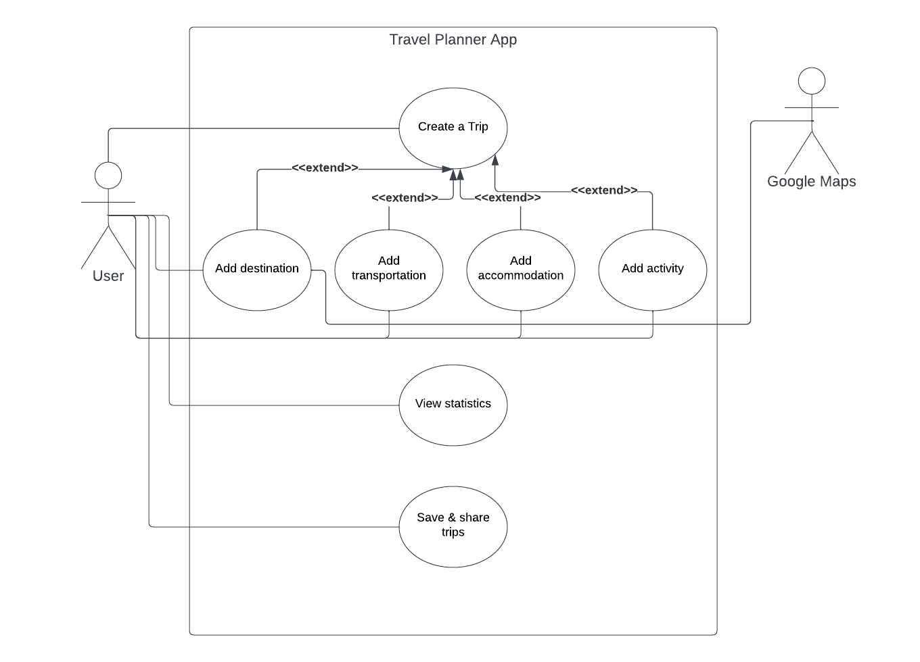

5. Database diagram
